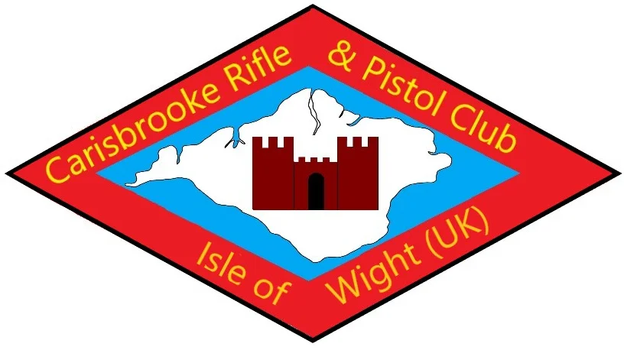

Carisbrooke Rifle and Pistol Clubs, All Ranges

Shooting Risk Assessment

Date: (1)  27/09/23 | Assessed by: (2) Wayne Challender | Checked / Validated* by: (3)  Terry Grant | Location: (4)  Carisbrooke Rifle and Pistol Club  All Ranges used by the Club. | Assessment ref no (5) | Review date: (6)  January 2025
Task / premises: (7)
Shooting Activities at all Shooting Ranges used by Carisbrooke Rifle & Pistol Club

Event (8) | Hazard (9) | Who might be harmed and  how (10) | Existing measures to control risk (11) | Risk rating (12) | Further Action (13)
Guests shooting with Airguns / Firearms (where appropriate and in accordance with Constitution and Byelaws.) | Stray Shots due to inexperienced use of Weapon. | Club Members & Guests | Standard operating procedure Guests are accompanied at all times by experienced Members, who are responsible for their Weapon and Guests conduct.  Only Members are able to fire Firearms. With relevent Section 1 Validation.  And the guest and member must be cognisant with the range safety rules and be fully briefed.  RCO Decision is FINAL. | Without control Likelihood – High Consequence - High With control Likelihood – Low  Consequence - High | None
Loud noise caused by Weapons being fired | Damage to hearing | Club Members & Guests. | Standard operating procedure Hearing protection MUST be worn by Everyone at all times eye protection is to be encouraged. | Without control Likelihood – High Consequence - Medium With control Likelihood – Low  Consequence – Medium | None
Event (8) | Hazard (9) | Who might be harmed and how (10) | Existing measures to control risk (11) | Risk rating (12) | Further Action (13)
Mal-functioning targets or guns | Injury to user of poorly maintained equipment | Users of equipment | Standard operating procedure Airguns and firearms regularly serviced | Without control Likelihood – Medium Consequence - High With control Likelihood – Low Consequence - High | None
Use of weapons under the influence of alcohol | Bravado and lack of co- ordination causing irresponsible behavior | Anyone in vicinity of user | Standard operating procedure Operation of guns at discretion of experienced instructor. Anyone deemed to be intoxicated or demonstrating poor responsibility to be removed from shooting area.  Test – Would you let this person drive a car? | Without control Likelihood – Medium Consequence - High With control Likelihood – Low Consequence - High | None
First aid facilities | Inadequate first aid available in case of accident | Injured person | First aid available in Comfort area. | Without control Likelihood – High Consequence - High With control Likelihood – Medium Consequence - High | None
Red Flags (Where Appropriate) | Members of the public wandering onto the range uninvited. | Members of the public/dog walkers | Ensuring red flags are flown and there is a non shooter alert to the fact of people, dogs or both wandering about.  Ensure the gate is locked and gate flag is clearly seen. | Without control Likelihood – Medium Consequence - High With control Likelihood – Low Consequence - High | None
leptospirosis  Otherwise known as Weil's disease | The Weil's disease form of leptospirosis is contracted from the urine of infected rats. The bacteria get into your body through cuts and scratches or through the lining of the mouth, throat and eyes after contact with infected urine or contaminated water. | Club Members, Guests and onlookers. | Washing hands with soap and water or using Hand gel, until at home when hands can be washed.  Do not eat or put hands in mouth or near open wounds. | Without control Likelihood – High Consequence - High With control Likelihood – Low  Consequence - Medium | None
Lead Poisoning | Coming into contact with lead from ammunition and pellets. | Club Members & Guests. | Washing hands with soap and water or using Hand gel, until at home when hands can be washed.  Do not eat or put hands in mouth or near open wounds. | Without control Likelihood – High Consequence - High With control Likelihood – Low  Consequence - Medium | None

Event (8) | Hazard (9) | Who might be harmed and how (10) | Existing measures to control risk (11) | Risk rating (12) | Further Action (13)
Covid 19 | A Member who has tested Positive for Covid 19 or suspects they are infected. | All Members | Any member showing symptoms of Corvid 19 to stay away from Range. | Without control Likelihood – High Consequence - High With control Likelihood – Low  Consequence - Low | None
Fires | Fires starting due to discarded cigarette Ends and use of tracer rounds, having fires on site. | All Members | The use of tracer and pyrotechnics is not allowed at the range - Open fires are not permitted - No smoking is allowed within the range - Fire Extinguishers and sand buckets are sited and regularly maintained - Emergency lighting is installed to aid egress through emergency exit within building. | Without control Likelihood – High Consequence - High With control Likelihood – Low  Consequence - Medium | None
Range Incursion | Unwanted Visitors | All Members (Only Validated Members can use live firing weapons.) | The range is secured with steel security gates. - Live firing only allowed under supervision of RCO – Air Horn sounds in emergencies to cease shooting. Direct access to range is by locked gate which is not allowed when firing is underway. | Without control Likelihood – High Consequence - High With control Likelihood – Low  Consequence - Low | None
Event (8) Hazard (9) Who might be harmed and how (10) Existing measures to control risk (11) Risk rating (12) Further Action (13) Slips and Trips Slips and Trips caused by wet and uneven ground or Roots Members.
Everyone advised to wear appropriate footwear and check path as you go.
Without control Likelihood – Medium Consequence - Medium With control Likelihood – Low Consequence – Medium None Lone Attendance A Medical Emergency with no possibility of help around.
Members Only Everyone is advised to let some know that you will be attending the Range, the time your going and the time you expect to return.
Carry a mobile phone. Without control Likelihood – Medium Consequence - High With control Likelihood – Low Consequence – High None Overall supervision and organisation of site Without effective responsibility and accountability the above operating procedures may lapse.
Anyone using the ground Operation of all shooting under the control of Carisbrooke Rifle and Pistol Club.
The allowance of shooting without Membership only allowed with a Current Member of the club in accordance with the Club Rules.
The Range is approved by the CRPC Without control Likelihood – Medium Consequence - High With control Likelihood – Low Consequence – High None

This Page is intentionally left blank

